
Response to Solicitation: Program Reporting Support
Response
Response to: QA example — program reporting support
Fictional demonstration office · Solicitation QA-ONLY-2026
Due November 20, 2026, 5:00 PM Eastern.

Submitted by Cedar Bridge Demonstration LLC
UEI DEMOONLY0001 · CAGE DEMO1
[[GAP: point of contact name, title, phone, email]]
2026-09-29
DRAFT prepared with KPsphere AI ScoutBOT. Replace every red item and verify all content against the solicitation. Before sending, delete this line and the AI notice below it, unless the solicitation requires you to disclose the use of AI.
AI-generated. KPsphere AI ScoutBOT drafted this from the solicitation and your company profile. Check every requirement, date, page limit and claim against the original notice before you rely on it. You are responsible for what you submit. KPsphere AI ScoutBOT does not submit anything on your behalf and is not legal, contracting or financial advice. It does not guarantee compliance or award.

Table of Contents

In Word: right-click the table and choose Update Field after your edits, so page numbers are right. Delete this line.

Finish and verify (delete this box)
- Replace red GAP markers with verified facts. Check the entire response against the notice; detailed instructions and the evidence checklist are in START HERE.
- Before sending: remove red notes and the DRAFT header, update the contents, export to the buyer’s required format, and check the final page count.
- This is Response: Single narrative file answering the two evaluation criteria in order and closing with a compliance section; read by the evaluation panel for the demonstration office. Buyer's rule for this file: 10 pages excluding cover; Arial 11 point, single spaced, one-inch margins. No file naming rule stated.

1. Describe the monthly reporting method and quality controls.
Criterion answered: the monthly reporting method and quality controls (60 percent). Our answer is a fixed five-step monthly cycle in which every step has one accountable role, a stated input, a named deliverable and a check that must pass before the next step begins, and in which no report is released while a material defect is open. This is a proposed method, not work already performed for this office; it would be confirmed against the government's template and data sources at kickoff.
Step 1 — Intake (working days 1 to 3). The Reporting Analyst collects the month's source data: program status inputs, schedule and milestone data, risk entries and any financial extracts the program office provides. Input required from the government: read access to the systems of record and one named point of contact for data questions. [[GAP: insert the government's required monthly report template, the named systems of record and the data fields to be reported; obtain it FROM the contracting officer or program office at kickoff; verify WHICH EVIDENCE — the report template or data requirements attachment]] Deliverable: a dated intake log listing every source, the date pulled and the person who pulled it. Check: each required field has a source; any missing field is raised to the program office the same day rather than estimated.
Step 2 — Drafting (working days 4 to 7). The Reporting Analyst drafts against the government template: status by milestone, variance against plan, open risks and issues with owner and due date, and actions carried from the previous month. Every figure carries a reference back to the intake log. Deliverable: draft report plus a traceability sheet linking each figure to its source.
Step 3 — Independent quality review (working days 8 and 9). A reviewer who did not draft the report performs the check. This two-person separation is the core control: the drafter never signs off their own work. The reviewer works from a written checklist covering (a) completeness against the template, (b) arithmetic and totals, (c) traceability — each figure resolves to a logged source, (d) consistency with the prior month and explanation of any change in method, (e) plain-language clarity, and (f) that no unsourced assertion appears. Deliverable: a completed checklist and a defect log entry for each finding, classified as material (affects a reported figure or status) or editorial.
Step 4 — Correction and sign-off (working day 10). The analyst corrects every logged defect; the reviewer verifies and closes each entry. The Program Lead reviews material defects, confirms that unresolved data gaps are stated in the report rather than filled with estimates, and signs for release. Acceptance check before release: zero open material defects and a signed reviewer checklist.
Step 5 — Delivery and acceptance (by working day 12, or a date agreed at kickoff). The Program Lead delivers the signed report to the contracting officer's representative with the defect log summary attached. Proposed government acceptance criterion: the report is complete against the template, figures trace to source, and no material defect is outstanding. We propose five working days for the government to accept or return with comments; returned comments are dispositioned within three working days and re-reviewed under Step 3 before re-delivery. We will adopt the government's own delivery day, acceptance window and format if they differ.
Reporting cadence. Monthly report as above; a one-page weekly status note (work completed, work planned, data access blockers, open risks) to the government point of contact; and a quarterly review covering trends across the three preceding reports, recurring defect causes and any proposed change to the template or method. Method changes are proposed in writing and applied only after the government agrees, so month-to-month comparability is preserved.
Quality measurement. Three measures are kept from month one: on-time delivery against the agreed date, material defects found at independent review per report, and defects found by the government after delivery. Trends go to the quarterly review with a root-cause note and one corrective action for any recurring cause — a repeated traceability defect changes the intake log fields, for example, rather than producing an exhortation. [[GAP: insert the performance thresholds the government expects for on-time delivery and post-delivery defects, if any are specified; obtain it FROM the contracting officer; verify WHICH EVIDENCE — the performance requirements or quality assurance surveillance plan]] We propose no thresholds the government has not stated.
Tools. The method needs a document template, a spreadsheet for the traceability sheet and a simple issue register for the defect log. It depends on no specialised software, so the first cycle can run on government-furnished templates. [[GAP: insert the specific reporting, spreadsheet and issue-tracking tools Cedar Bridge Demonstration LLC will license, with license counts and cost basis; obtain it FROM company operations records; verify WHICH EVIDENCE — vendor quotes or purchase records]]
Contingency. If a source system is unavailable during intake, the affected section reports 'data unavailable' with the outage date, the government contact is notified, and the figure is supplied in a supplement once access is restored; no figure is estimated. If the Reporting Analyst is unavailable, the Program Lead drafts and the backup reviewer performs the independent review, preserving the two-person rule. If the independent reviewer is unavailable, the report is held until a second qualified reviewer completes the checklist: late delivery with a complete check is preferred to on-time delivery without one, unless the government directs otherwise in writing. Templates, checklists and logs sit in a shared company repository so a qualified person can pick up the cycle mid-month.
Evidence. Cedar Bridge Demonstration LLC claims no government prime past performance. [[GAP: insert one comparable reporting engagement — client, year, dollar value, deliverables produced and a reference contact — attributed to the individual and the employer where it was performed; obtain it FROM Alex Example or other proposed staff; verify WHICH EVIDENCE — a contract, purchase order or signed reference letter]]
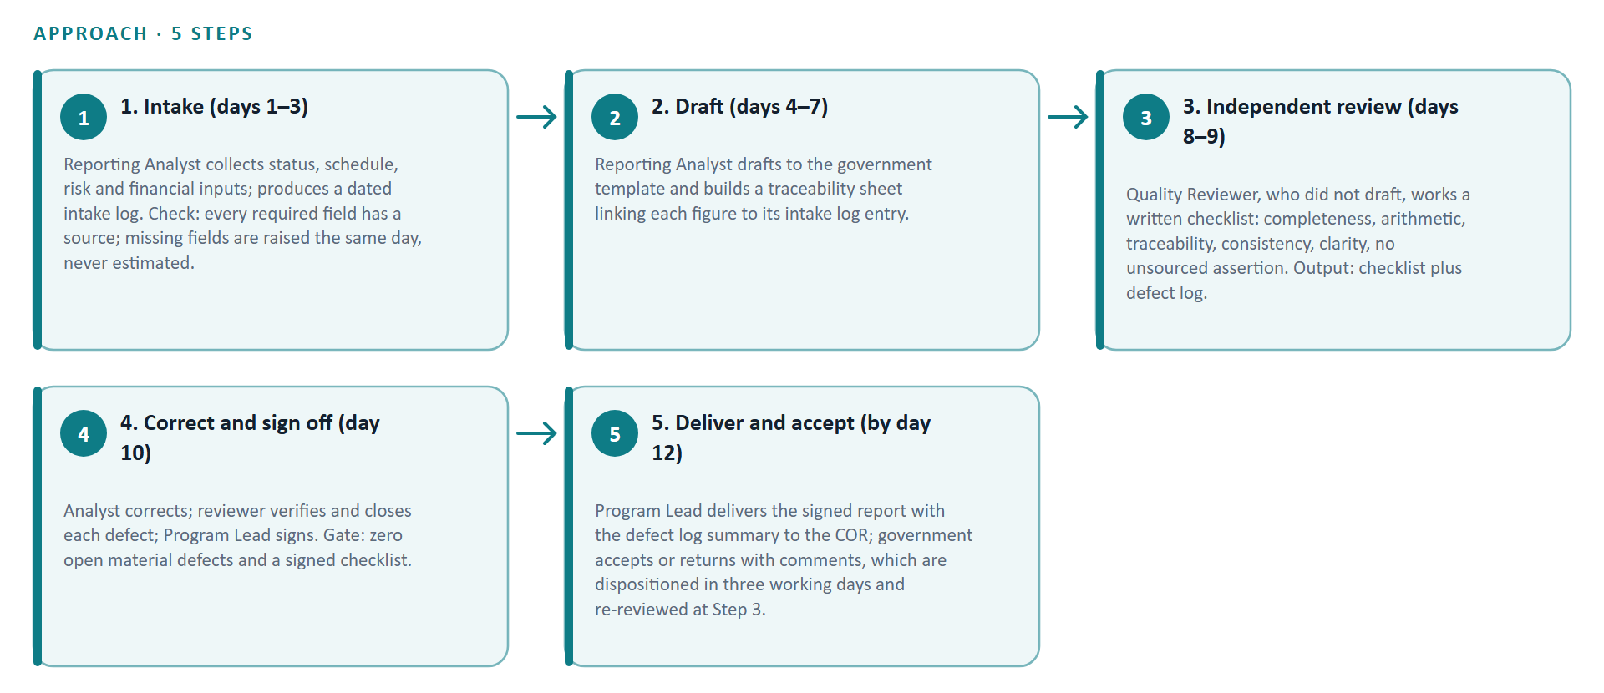
Figure 1. Our approach, step by step.
ADD HERE, then delete this box
- Complete the red markers in this section. The START HERE guide lists exactly what evidence to collect and why for this section.

2. Identify the proposed roles and the mobilization plan.
Criterion answered: the proposed roles and the mobilization plan (40 percent). The cycle above requires three duties — drafting, independent review and sign-off — and the review duty must be performed by someone other than the drafter. We therefore propose three roles and no more; staffing is sized to the cycle, not to headcount.
Program Lead (part time). Accountable for delivery and acceptance, signs each monthly report, chairs the quarterly review, owns the corrective action list, and is the government's single point of contact. Proposed: Alex Example, described in the company profile as proposed program lead and available subject to confirmation. This is a proposed role, not a confirmed start. [[GAP: insert Alex Example's résumé — years of program reporting experience, education and any certifications, prior employers with dates — and a signed letter of availability with a start date; obtain it FROM Alex Example; verify WHICH EVIDENCE — the signed availability letter and employment references]]
Reporting Analyst (full time during the reporting cycle). Performs intake, maintains the intake log and traceability sheet, drafts the report and corrects logged defects. Status: prospective hire; no individual is confirmed.
Quality Reviewer (part time, monthly). Performs the independent checklist review, classifies and logs defects, verifies corrections. Must not be the drafter. Status: prospective hire, or a second qualified employee cross-trained to back up the analyst.
Confirmed employees, prospective hires and subcontractors. Confirmed employees assigned to this work: none at the time of writing. Prospective hires: Reporting Analyst and Quality Reviewer, recruited on the sequence below. Proposed subcontractors: none. [[GAP: insert the names, labour categories and committed start dates of any employees already on payroll, and any signed teaming or subcontract agreement if a subcontractor is added; obtain it FROM company payroll and contracts records; verify WHICH EVIDENCE — payroll records and executed agreements]]
Recruitment and qualification checks. We recruit against a written position description stating required reporting experience, spreadsheet and writing skills. Candidates complete a practical exercise — draft a one-page status section from a sample data set and find three defects in a flawed sample report — scored by the Program Lead against the same checklist used in monthly review. Employment history and education are verified with named prior employers before an offer; identity and work authorisation are confirmed at hire. [[GAP: insert whether the government requires background investigations, badging or facility access for contractor staff, and at what level; obtain it FROM the contracting officer; verify WHICH EVIDENCE — the security or access requirements in the contract documents]] We claim no clearances.
Onboarding. Within the first five working days a new team member receives the position description and review checklist, a walkthrough of the intake log, traceability sheet and defect log, a supervised dry run on the prior month's data, and written rules for handling government data. No one drafts or reviews a deliverable for release until the Program Lead has signed off their dry run.
Supervision and backup coverage. The Program Lead supervises both positions, reviews every defect log and holds a 30-minute internal cycle check each week. Coverage is designed in: the Quality Reviewer is cross-trained to draft and the Program Lead is qualified to review, so a single absence still leaves two different people covering drafting and independent review. Planned absences are notified to the government point of contact in the weekly note.
Mobilization plan (proposed, counted from notice to proceed). Days 0–2: Program Lead confirms start, contacts the contracting officer's representative, requests the kickoff meeting, report template and system access. Days 1–5: kickoff; confirm template, delivery day, acceptance window and points of contact; issue position descriptions and open recruitment. Days 3–10: screening and practical exercise; reference and education checks. Days 8–12: offers made and accepted; onboarding begins. Days 10–15: full-cycle dry run on the most recent completed month, producing a sample report and defect log shared with the program office for comment. By the end of the first full reporting month: first live report delivered under the five-step cycle with an independent review completed.
Mobilization dependencies and recovery. Three dependencies sit outside our control: the kickoff date, the date read access to the systems of record is granted, and any access, badging or investigation requirement imposed on staff. If access is delayed, the dry run proceeds on government-supplied sample or historical data so the method and checklist are proven before the first live report. If a hire is delayed, the Program Lead drafts and the Quality Reviewer performs the independent review, preserving the two-person rule at reduced throughput, and the shortfall and its recovery date are reported in that week's note.
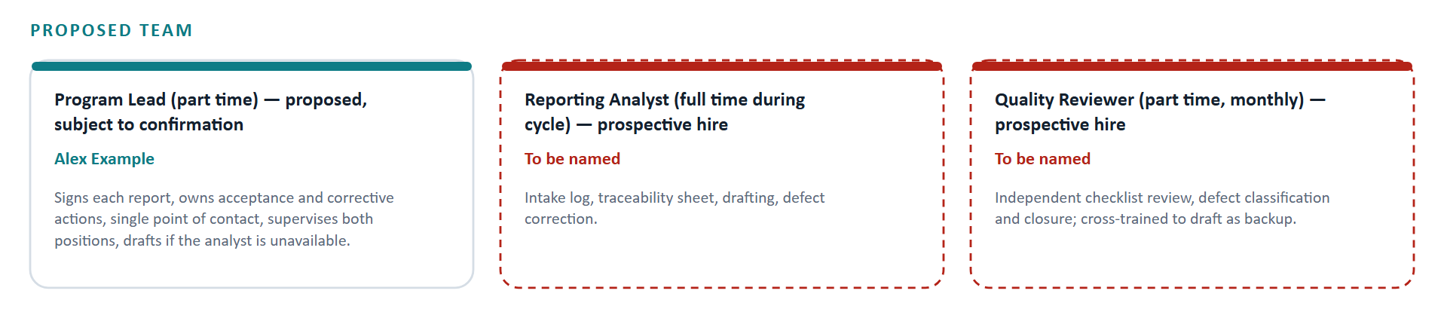
Figure 2. Proposed team and responsibilities.
Role | Name | Responsibility
Program Lead (part time) — proposed, subject to confirmation | Alex Example | Signs each report, owns acceptance and corrective actions, single point of contact, supervises both positions, drafts if the analyst is unavailable.
Reporting Analyst (full time during cycle) — prospective hire | [[GAP: name]] | Intake log, traceability sheet, drafting, defect correction.
Quality Reviewer (part time, monthly) — prospective hire | [[GAP: name]] | Independent checklist review, defect classification and closure; cross-trained to draft as backup.
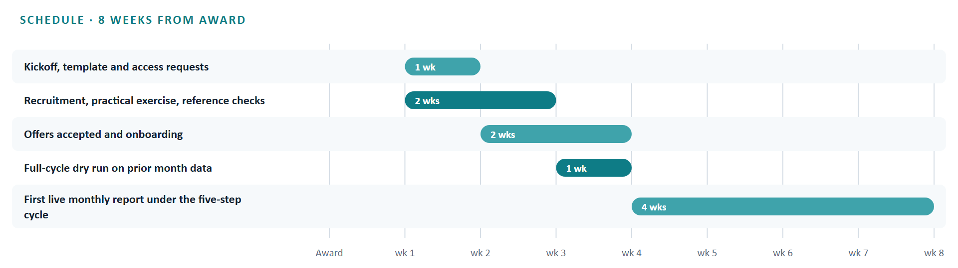
Figure 3. Proposed schedule in weeks from award.
ADD HERE, then delete this box
- Complete the red markers in this section. The START HERE guide lists exactly what evidence to collect and why for this section.

3. Compliance and administrative information
Compliance with the notice's stated conditions is addressed here in the notice's own terms; nothing is added from a generic checklist.
Format. This response is prepared in Arial 11 point, single spaced, with one-inch margins, and is organised in the order of the two evaluation criteria. The notice sets a limit of 10 pages excluding the cover; the rendered page count is confirmed on export and is not asserted here. The notice states no volume structure, file naming rule or typography beyond the above, so none is assumed.
Submission. The notice states that this is a demonstration only and that the response is not to be submitted. The stated due date is November 20, 2026, 5:00 PM Eastern. No portal, email address or copy count is given.
Identification. Legal name: Cedar Bridge Demonstration LLC. Primary NAICS code: 541611. The company holds no certifications and claims none. [[GAP: insert the Unique Entity Identifier and CAGE code for Cedar Bridge Demonstration LLC; obtain it FROM the company's registration record; verify WHICH EVIDENCE — the active SAM registration printout]]
Eligibility. The notice records its eligibility verdict as unclear and provides no eligibility text. Accordingly no set-aside status, size standard or registration condition is asserted. [[GAP: insert the eligibility and any set-aside or registration condition that applies to a live version of this requirement; obtain it FROM the contracting officer; verify WHICH EVIDENCE — the solicitation's eligibility clause and the company's registration record]]
Forms and certifications. The notice lists no forms, representations or certifications to be attached. None are included.
Assumptions. Two planning assumptions underlie this response and should be confirmed before any live use: that the government supplies the monthly report template and read access to the systems of record, and that the government accepts or returns each monthly report within a defined window. Both are proposed positions, not agreed terms.
ADD HERE, then delete this box
- Complete the red markers in this section. The START HERE guide lists exactly what evidence to collect and why for this section.

